COLLEGE OF HUMANITIES AND SOCIAL SCIENCES

HOW TO GRANT USER RIGHTS TO THE MEMBERS IN YOUR SCHOOL / DEPARTMENT

Step1. Login.
Step 2: Go to the People Link:

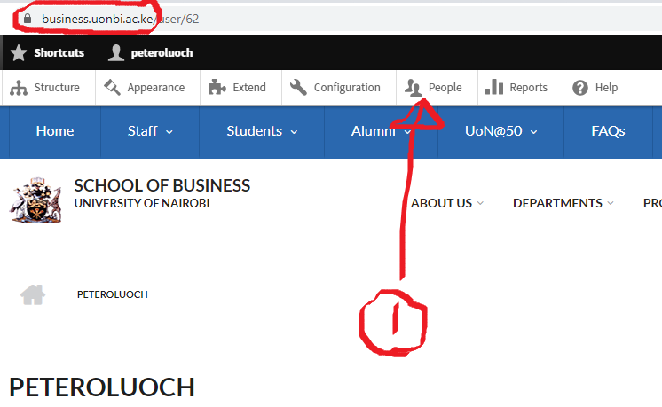

Step 3: Add User.

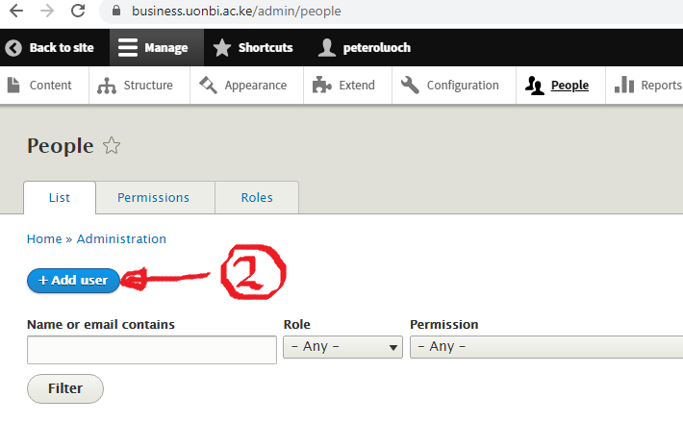

3. To Edit any user rights : Click on any user and click edit
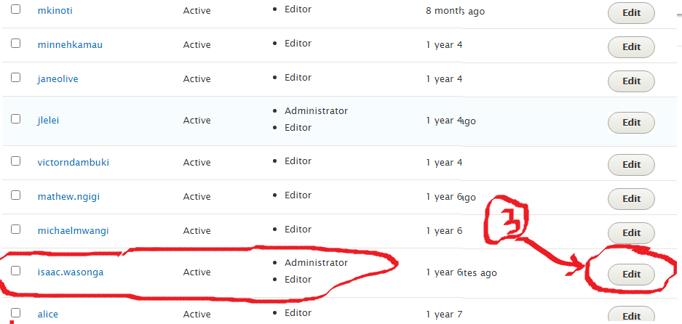
4. Either Add User / Edit User as needed
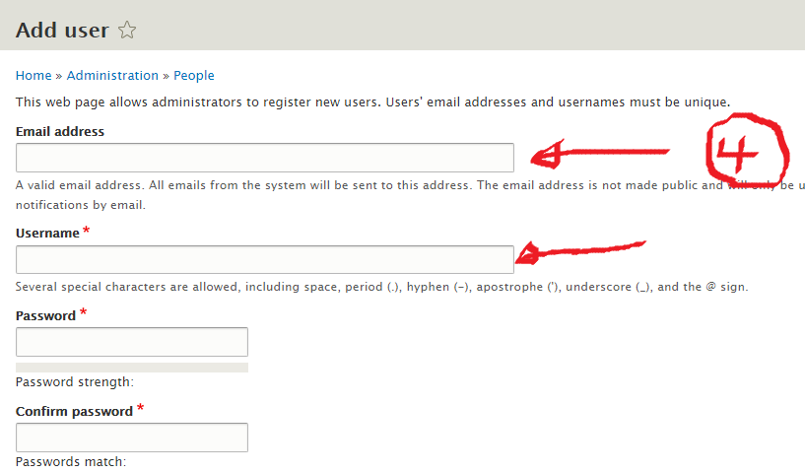

5. Assign the user rights: Please choose Editor Rights.

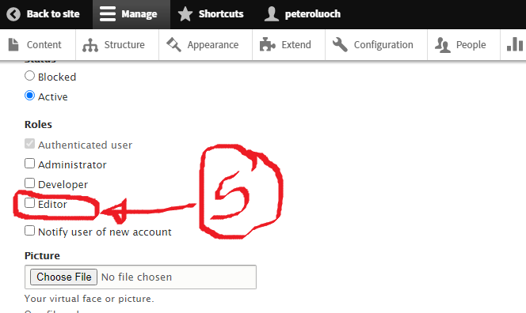

Step 6: Click Create New User / Edit User
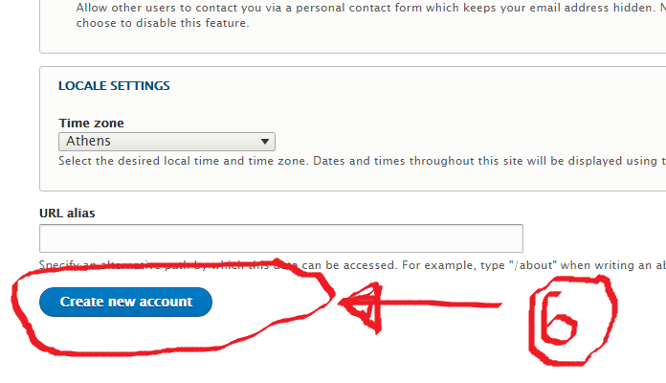

Step7: Click SAVE
